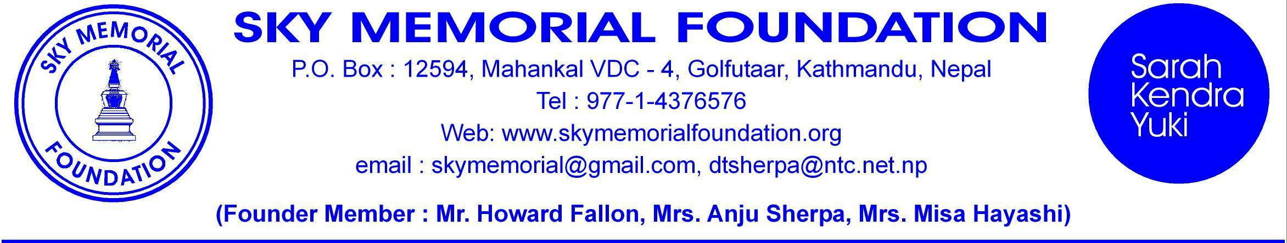
The Chairman,
Mrs. Phurba Sherpa,
Greater Himalayas Foundation,
USA May 26, 2012
Dear Mrs. Sherpa,
Subject: Establishment of SKY MEMORIAL FOUNDATION..
This is to inform you that SKY Memorial Foundation have been formally registered at the Ministry of Homes –Kathmandu District Administration, Ministry of Local development – District Development Committee and affiliated with the Social Welfare Council. Our Registration number is 910/68/69. We are pleased to inform you that our foundation has been registered as Tax Free so all the donors and sponsors can get tax rebate from the government of Nepal.
Kindly find attached the copy of the Sky Memorial Foundation’s certificate, Tax exemption paper and the certificate of affiliation with the Social Welfare Council of Nepal.
We have a bank account at the Everest Bank Limited in Kathmandu. The account details are as follows:
Account Name: SKY Memorial Foundation
Name of Bank: Everest Bank Limited Nepal. www.everestbanklimited.org
Account Number: 02800105200275
SWIFT CODE : EVBLNPKA
Email of Bank : ebl@mos.com.np
We request you to kindly send the donations in the above mentioned bank account. We shall send you the formal receipt from the bank and then quarterly report of the work being carried out. We will be visiting the village next month and shall send you photos of the school and the children.
Thanking you and looking forward for your generous support and hope to have a long relationship with your organization.
Yours truly,
Dorji Tsering Sherpa
Chairman
SKY Memorial Foundation.
www.skymemorialfoundation.org

