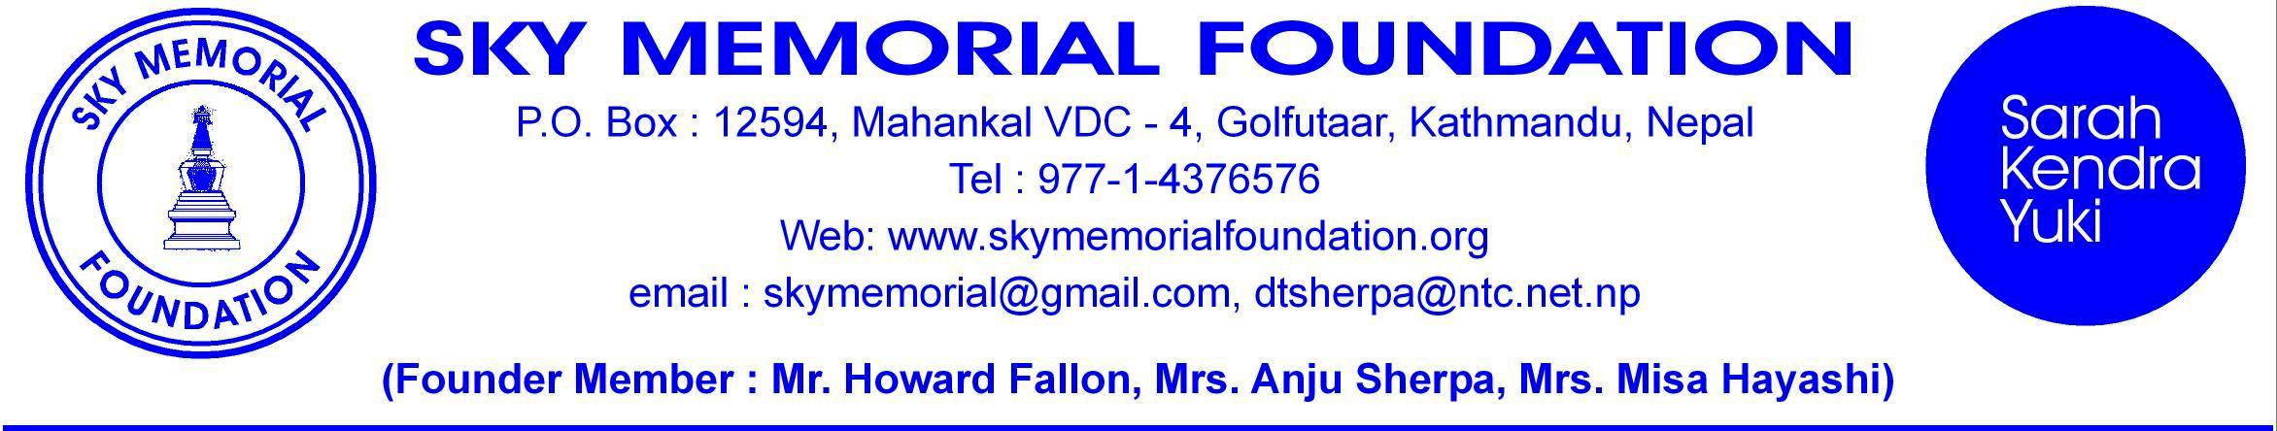

January 8, 2013

Subject: Support for Girls.
Pleased to inform you that our foundation SKY Memorial Foundation (SMF) Nepal has been registered at the Kathmandu District Administration Office and formally tied up with the National Social Welfare Council. SMF-USA has also been formally registered in USA by Mr. Howard Fallon. The foundation is established in memory of our daughters Sarah-Kendra and son Yuki. It is a non-profit making and tax free social organization.
SHIKHARPUR VDC in Makawanpur district, where the airplane had crashed taking the lives of 14 along with our daughters and son, is about eight hours drive from the Kathmandu valley. The villages are in remote area with rough motor track which will be inaccessible during the monsoon. There are nine wards in the VDC and each ward has public schools which are in a poor condition. The following schools are being supported by us and with help from various other generous individuals and organization.
1: The Bakiya Thakur Middle School at Ward #2 (314 students) established 36 years ago was a primary school and with our help it is upgraded to a middle school from this year. We have built 3 buildings, provided furniture, salary for 4 teachers and other basic needs. Monthly allowances for 64 girls and boys are being provided to encourage them to attend school regularly. We still need support on a long term basis.
2: The Namo Buddha Primary School – Ward #1 (106 students) have been provided with new class room, toilets renovation, extra teacher and monthly allowances for 12 most underprivileged children.
3: The Rhisheswor Primary School – Ward #8 at Phaparbari (50) have been provided with new roofs, new toilet, and extra salary for 2 teachers, 10 benches, tables, school bags, 50 pair of slipper for each student. We have recently provided fund for the drinking water pipe line and water tanks to the school.
4: The Jan Jagriti Middle School – Ward #3 ( 434 students) have been provided with new roofs, a new class room for the Play Group class, extra salary for 2 teachers, a computer for the senior classes.
5: Shree Mahankal Primary School – Ward #7 at Phaparbari (50 students) have been provided with new class room, roofs, tables and chairs, monthly allowances for 13 most under privileged children to attend school regularly, bags, slippers, stationery and extra salary for a teacher, water pipe line and toilet is being constructed. The fund is being provided by the Scandinavian Help Denmark. They also provide allowances to 22 girls of class V to complete their High school.
6: We have provided School bags, slippers, stationery to the students of Bakiya Thakur (300), Jan Bhavna Primary school (105), Goth Danda Primary School (106), Shree Mahankal and Rhisheswor Primary School (100). There are 6 other primary schools where such support is needed.
7: We have donated computer to Bakiya Thakur, Jan Jagriti, Buddha Higher Secondary School, Janta Higher Secondary School and to Kali Devi High School. We have also provided books for the library at these Higher Secondary Schools. We have arranged Volunteers to visit the school and teach English and conversations.
8: “SKY-MICHIKO-HEALTH CLINIC” will be inaugurated this year at the building that SKY Memorial Foundation has constructed at Bastipur Ward #2 near the Bakiya Thakur School. The Clinic will have a health assistant that will provide basic health care and medicine to the villagers of 5 wards around it. We need more support to provide services to the 3000 people.
Your contribution is supporting the further studies of the girls in Nepal. SKY Memorial Foundation (SMF) will initiate, coordinate and arrange necessary monitoring and ground work support for proper utilization of the funds you contribute. If you like we can arrange for your visit to the villages when you travel to Nepal.

Dorji Tsering Sherpa
Chairman
SKY MEMORIAL FOUNDATION.
Kathmandu, Nepal.

