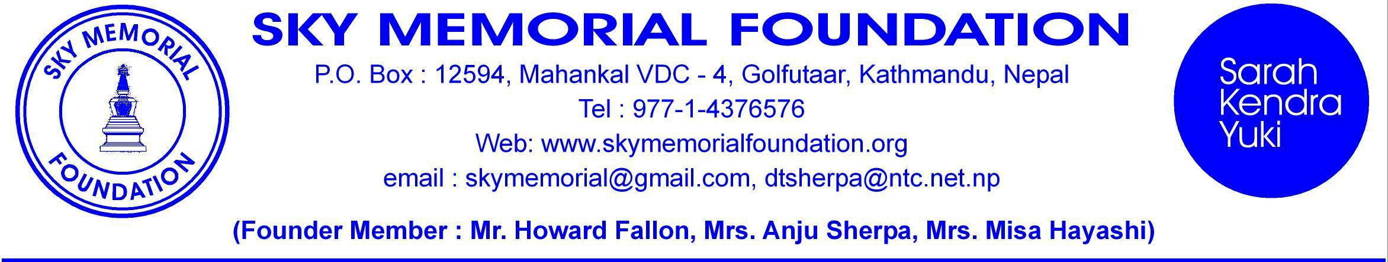

BRIEF DETAILS OF THE WORK ACCOMPLISHED

First of all I would like to express my heartfelt condolences on the sad passing away of many Nepalese by the horrible earthquake of the April 25th 2015 and subsequent aftershocks here in various part of Nepal.

We SKY Nepal received great support and trust from many friends and family from all over the world. It was really amazing and great. So we carried our work out of Kathmandu valley to other four Districts of Nepal. Please have a look at the places and organizations that SKY have helped and are still carrying on the work:-

1: Immediately after the earthquake the TRAUMA CENTER HOSPITAL in Kathmandu was flooded with patient and caretakers. The Hospital chief requested us to help provide meal to the 250 or so. We agreed to provide evening meal for 5 days and later we continued for 10 days. There were no restaurants or sufficient staff in the center since many had fled Kathmandu so we had to help in the kitchen and served meal to all the patient and caretakers.

2: We then concentrated on the small organizations of orphanage, disabled children and women inside the Kathmandu valley who were the most vulnerable. They could not escape nor run out of their miserable shelters. Rice, lintels, oil, milk powder, Blankets, Tarpaulin and cash for each were distributed to ASHNA (12) VCD (10) , EPSA (15), ASC (17), CVDS(32), KNLDH(60) and 20 Blind disabled.

3: As the donation commitments from abroad increased we decided to go out of Kathmandu to the most affected area. The first area selected was the Pipal Danda at SINDHUPALCHOWK 6 hours drive away. Jointly with the residence of Galfutar we SKY contributed Rs. 80,000 worth of rice and lintels. I went there in a jeep and 2 trucks of food grains.

4: Our next visit was to the west in the district of DHADING for the 120 family. We provided 3810 kg or rice, sufficient lintels, salt, sugar, tarpaulin and blankets to 40 families.

5: We were then requested by the people of NUWAKOT where no relief materials had been distributed for 60 families. So we went there with 60 bags 1800 kg of rice, lintels, salt, sugar, oil, tarpaulin and blankets and many other materials.

6: We had to visit the Makawanpur district where we have 16 schools and other projects going on. So we went with relief materials and cash for immediate repairs and maintenance of the schools. We distributed 210 Blankets, 20 Tarpualine, 50 kg Milk powder, soap, antiseptic, sanitary towels, solar lamps and cash of Rs. 5000 each to the schools. We distributed Rice, dal, tarpaulin, and cash of Rs. 20,000 to three organizations in Hetauda. An orphanage of 52 boys, disabled senior citizens 30 and 35 boys and girls disabled ones.

7: We also invited all our Senior citizen of Bastipur and distributed special Blankets, Milk Powders and other food stuff to the 35 who came. We also gave 10 blankets and tarpaulin to the women committee of Bastipur.
8: We have initiated special vegetarian meals for 70 severely disabled men and women in Khagendra New Life Disabled Home in Jorpati every Friday for 3 months.

9: We have provided financial support of Rs. 1,40,000 for Road construction in two villages where we have our Michiko School and Manthali village which will join Anju Marga road of SKY. All this will make the SKY Village Bastipur the center of Shikharpur VDC.

It has been a great honor to be able to do so much for so many grief stricken people in various parts of Nepal because of your generosity and kindness. It has been a bit hectic but was a great pleasure to be able to be a part in this humane cause.

Thanking you and hoping to get your support as always. We have still sufficient fund for some more relief works that we will support in the coming days when monsoon will surely affect many villages and poor people.

Yours Truly,

Dorji Tsering Sherpa
Chairman
SKY MEMORIAL FOUNDATION.(SKY)
www.skymemorialfoundation.org

June 16, 2015.

